Student Name: __________________
Class and Section __________________
Total Points (20 pts) __________________
Due: Nov 30, 2016 before the class

Project: Racing Car

CSCI 1302 Advanced Programming Principles
Armstrong State University

Problem Description:
Write a Java program that simulates car racing, as shown in Figure a. The car moves from left to right. When it hits the right end, it restarts from the left and continues the same process. You can use a timer to control animation. Redraw the car with a new base coordinates (x, y), as shown in Figure b. Also let the user increase/decrease the car speed by pressing the CTRL+ and CTRL- keys.
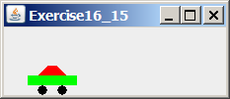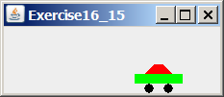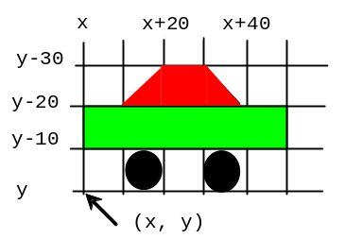

(a) (b)

Design:
(Draw a sketch of UI)

Coding:
Name your main class Exercise15_29

Screen shots:

Submit the following items:

1. Submit a hard copy of this document.

2. Compile and Submit to LiveLab as Exercise15_29 (you must submit the program regardless whether it complete or incomplete, correct or incorrect)

3. Fill in self-evaluation:

- Can you draw the car correctly? _____
- Is the car moving? _____
- Is the car moving circularly? _____
- Does the speed increase and decrease with the CTRL+ and CTRL- keys? _____

